Armand Punjabi

**Final Report: Climate Change Capstone**

**Problem Statement:**

This project is focused on exploratory data analysis of global land temperature. How can global land temperature data be analyzed to view the extent of climate change in the 21st century? Can it be measured to determine if the earth is indeed getting warmer? Analysis of this data aims to find out the rate at which the earth is getting warmer, and what areas have seen the greatest increase in temperature increase. This project is also focused on data visualization, and allows a user of the dashboard to take a look at individual countries to get an understanding of their temperature history.

**Data Wrangling and Cleaning:**

The data was sourced from Berkley Earth via Kaggle. The dataset had 577462 rows, and 4 columns. Missing data was then identified, and filled in using the ‘ffill’ method. Only 5.5% of rows were missing values for ‘Average Temperature’. The ‘Date’ column was then transformed into standard format. Since this project only focuses on the last 100 years of available data, all rows prior to 1/1/1913 were dropped. This was determined based on the accuracy of the data, and due to the fact that data was not recorded for most countries until the start of the 20th century. This reduced the dataset down to 291,736 rows. All work was done in a Jupyter notebook, and then saved as a .csv file and loaded into Tableau public.

**Data Visualization:**

Data was visualized and presented in Tableau Public. The dashboard was separated into multiple tabs for viewing, and can be navigated by clicking on the different tabs at the top of the screen. An interactive World Map was created to visualize average temperature by country. The color shading indicates temperature, with red being warmer and blue being colder.

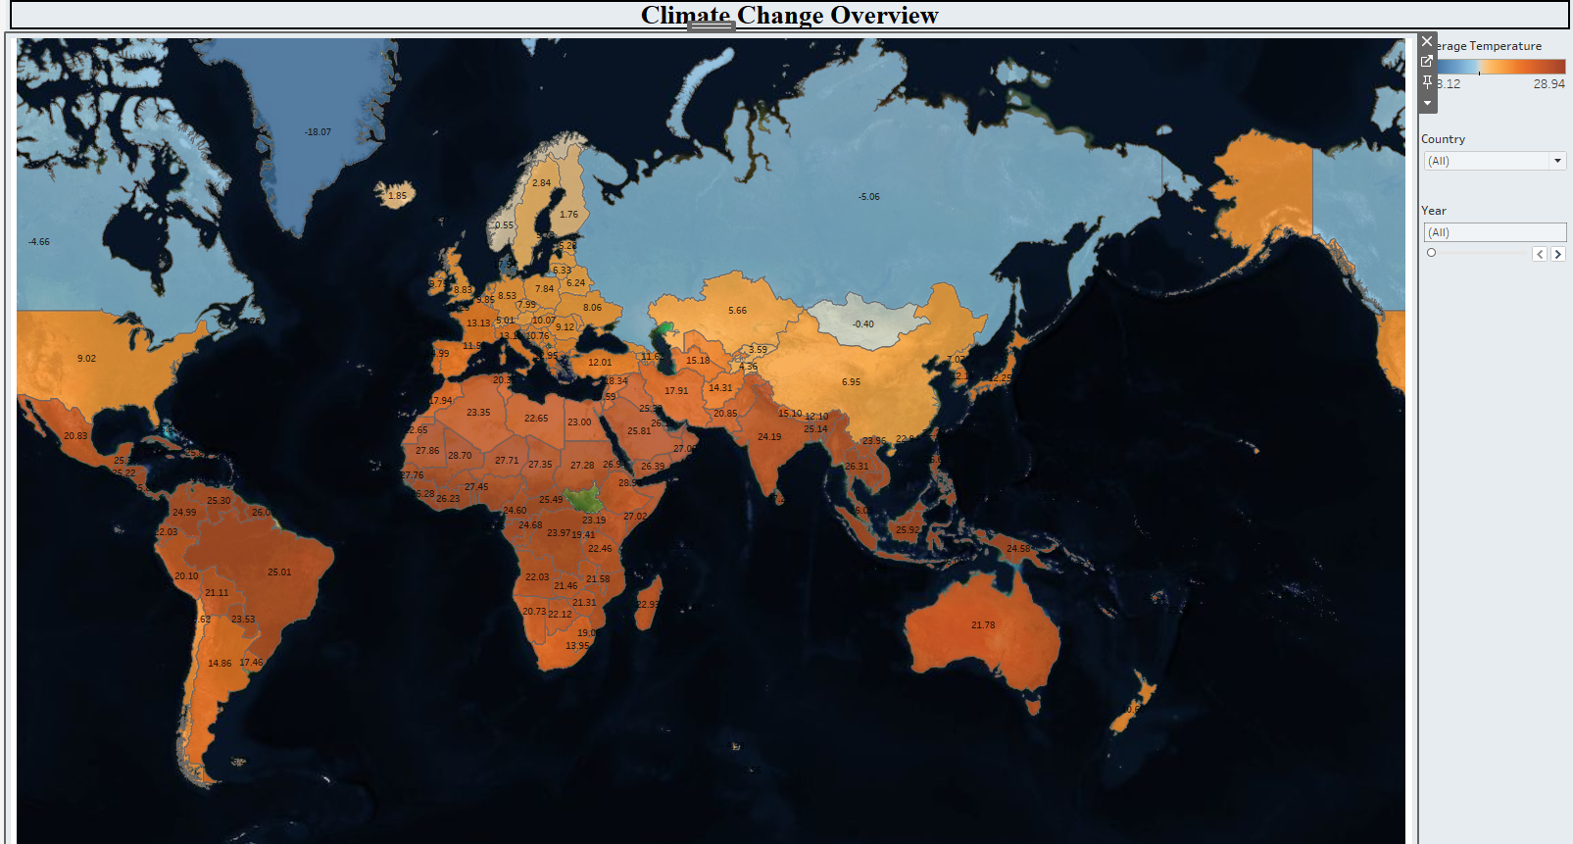

Further analysis of the changes in temperature from 1913 - 2013 shows that the planet got 9.268% warmer during that time. Furthermore, the last two decades of data have seen larger than 3% increases in temperature compared to the previous 10 years! It is evident that the planet is getting warmer at an increasing rate.

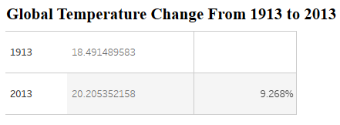

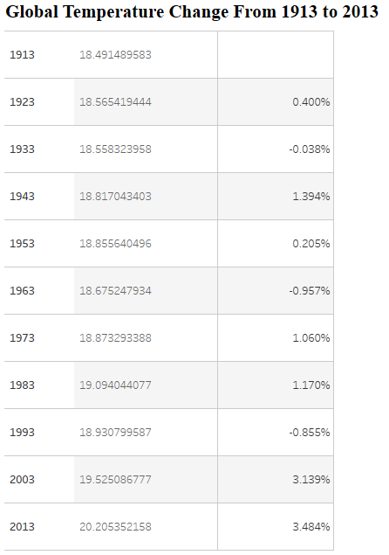

Taking a look at the warmest countries in the world, it is clear that these countries are not seeing as large of an increase in temperature compared to the global average. Countries around the equator have only gotten slightly warmer over this 100 year span.

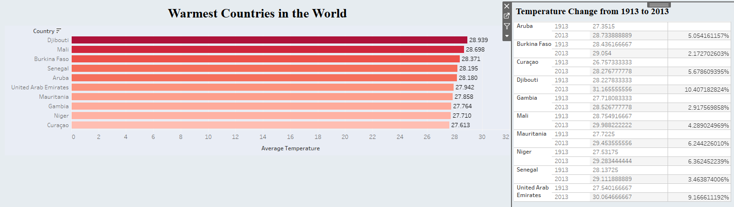

Conversely, the coldest countries in the world have seen massive increases in average temperature over this 100 year span. Countries near the north pole have seen huge jumps in average temperature, with many seeing over 100% increases!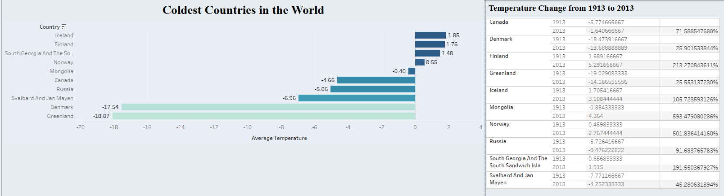

**Takeaways:**

It is clear from this analysis that the planet is getting warmer as a whole. The largest increases have been occurring in the last two decades, specifically within the colder countries in the world. Countries near the north pole are seeing huge increases in temperature, which can ultimately affect life on these lands. It is possible that temperature continues to rise in the following decades, with colder countries being affected the most.

**Further Research:**

There are several questions that this project brings to light, and many can be explored further. What are some of the primary causes of this increase in global land temperature in the 21st century? What should the priorities be to slow down this rate of temperature increase? How can awareness of this temperature increase be spread, and what areas of the world are likely to see the biggest change in day to day lifestyle if global temperature keeps rising? Research could be conducted to find answers to these questions, as climate change and increasing temperatures undoubtedly form issues for humankind in the centuries to come.